1. The image is shown below:



1. According to my monitor, it is a little difficult to see the different shades of black in the first column, especially the first 4 rows.
2. The new modified image is shown below:



The best power I used is 0.6500 as it allows me to see each shade clearly and allows me to differentiate them clearly.

1. Local averaging resulted in the edges to be shown in the image of cameraman.
2. The following is the final image:



Here, it is shown that the prominent areas that differentiated the foreground from the background have been highlighted. Thus, one could say that the edges of the foreground structure have become very prominent by making them white

1. On viewing the new image via imagesc() method results in the following image:

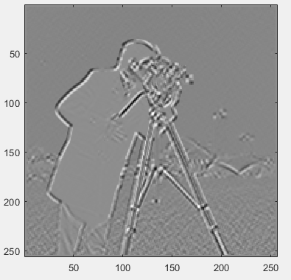

Here, the edges are being viewed differently. The subtraction essentially changed the color of the edges when viewed in gray scale.

1. I found that using the copper colormap brings greater definition as shown below:

